**WARP...What is it Good For?**

Wins Above Replacement Player, or **WARP** for short is a new age statistic to try to derive value of players. It was first seen in some version in Bill James' book *Baseball Abstracts* in the 1980s[3](https://github.com/damienfranco/MLB_WARP_vs_Salary#user-content-fn-3-40933b22192925ea7b2595dee463ecef).

[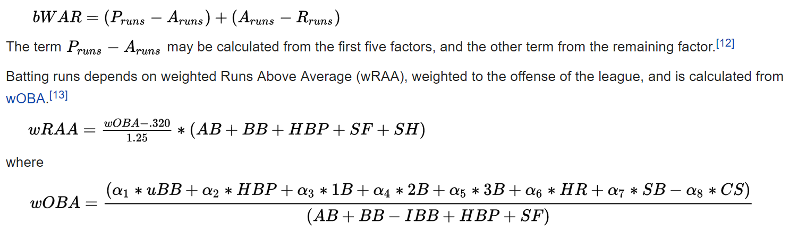](https://github.com/damienfranco/MLB_WARP_vs_Salary/blob/main/Presentation_Resources/WAR-Formulas.png)

The above looks DENSE. So what does it mean?

**WARP MADE EASY**

](https://github.com/damienfranco/MLB_WARP_vs_Salary/blob/main/Presentation_Resources/WAR%20Chart.webp)](https://github.com/damienfranco/MLB_WARP_vs_Salary/blob/main/Presentation_Resources/WAR%20Chart.webp)

**WARP** measures a player’s value in all aspects of the game in order to determine if how many "wins" that player is worth on the filed vs the average player:

* Negative WARP means a player is costing you wins
* 0 WARP means the player is average
* Any other WARP score means the player is above average and helping your baseball team succeed.